CREATE ROLE SISEU_DATAREADER

CREATE OR REPLACE USER SISDS_USER password='*******' Must_Change_Password = FALSE;

GRANT ROLE SISEU_DATAREADER TO USER SISDS_USER;

GRANT USAGE ON DATABASE DW TO ROLE SISEU_DATAREADER

GRANT USAGE ON SCHEMA DW.SIS TO ROLE SISEU_DATAREADER; --Confirm again USAGE ON SCHEMA exists or not if not run again post below REVOKE USAGEs are accomplishes

---Create User Script --------

CREATE USER "kriti.paliwal" password='************' DEFAULT_ROLE = SISEU_DATAREADER Must_Change_Password = FALSE;

GRANT ROLE SISEU_DATAREADER TO USER "kriti.paliwal";

------ Below Scripts does not work on Revoke Hence Please refer below snapshot TO REVOKE USAGE ON SCHEMAS------

//REVOKE USAGE ON SCHEMA "DW"."BASE" FROM ROLE SISEU_DATAREADER;

//REVOKE USAGE ON SCHEMA "DW"."CONTROL" FROM ROLE SISEU_DATAREADER;

//REVOKE USAGE ON SCHEMA "DW"."KEY" FROM ROLE SISEU_DATAREADER;

//REVOKE USAGE ON SCHEMA "DW"."PUBLIC" FROM ROLE SISEU_DATAREADER;

//REVOKE USAGE ON SCHEMA "DW"."REFERENCE" FROM ROLE SISEU_DATAREADER;

------------------------------------------------------------------------------------------------

Under Snowflake instance: Click on **Database** (spotted (1))

Then click on all Schema except SIS Schema, click on all the schema and when we will find Role SISEU_DATREADER then, click on **Edit** button (spotted (2)).

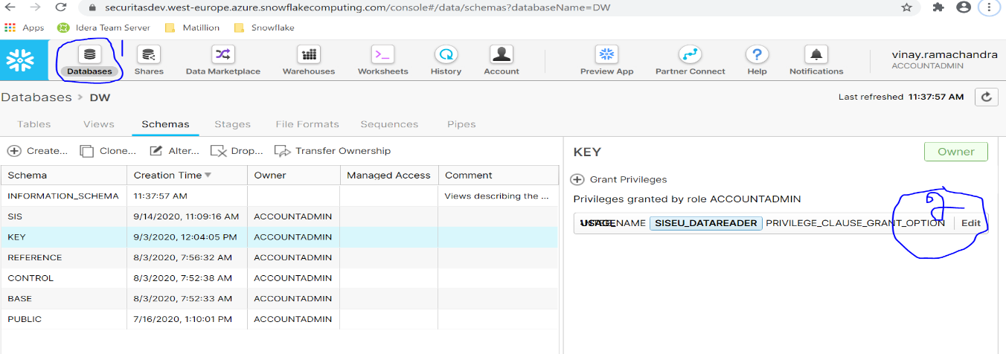

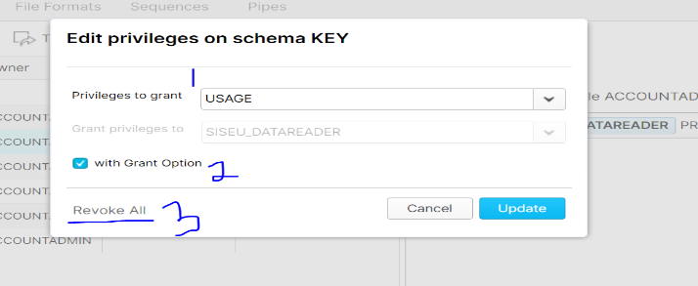

1. Select Privileges in Grant select **USAGE,   
2. Select check box with Grant Option and 3. Click on Revoke All**

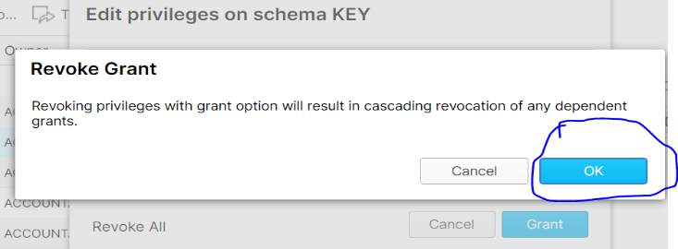

**Then Click ok   
Repeat the same steps for all Schemas, if we found role PUBLIC including SIS Schema.**